Project Report Templates

1.Introduction

* 1. Overview

Basic mathematical concepts are easily to teach for students.

* 1. Purpose

Motivational of mathematical concepts for slow learners.

2.Problem Definitions and Design Thinking

2.1 Empathy Map

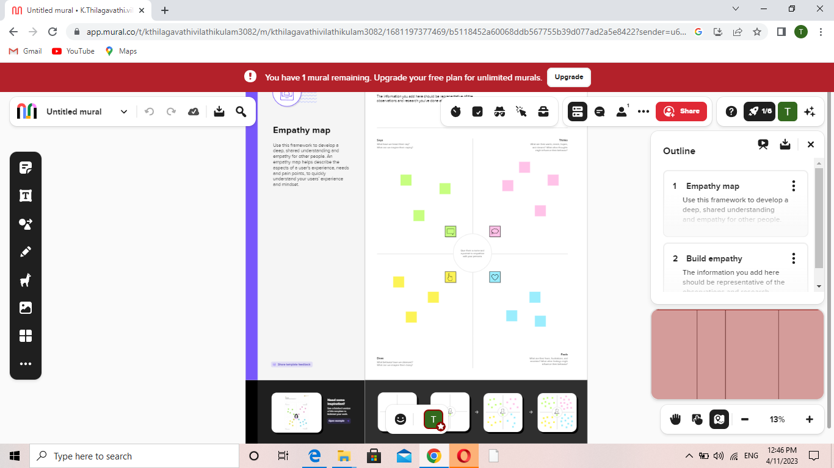

2.2 Ideation and Brainstorming Map

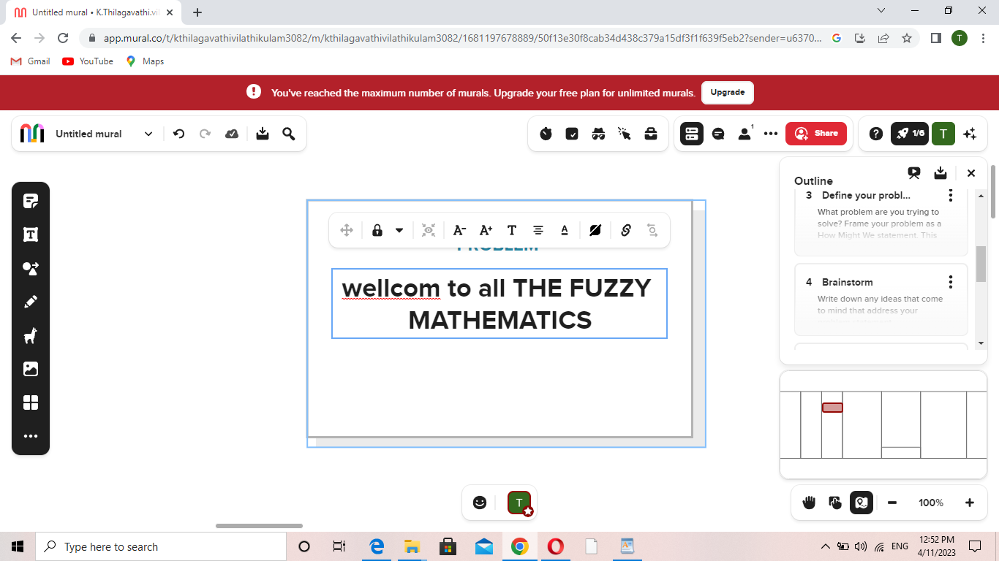

3.Result

3.1 Data Model:

|  |  |
| --- | --- |
| Object Name | Fields in the Objects |
| Fractions addition | |  |  | | --- | --- | | Field Label | Data Type | | Add | float | | Sub | float | |
| Fractions Multiplication | |  |  | | --- | --- | | Field Label | Data Type | | Multiply | float | | Divide | float | |

3.2 Activity and Screenshot

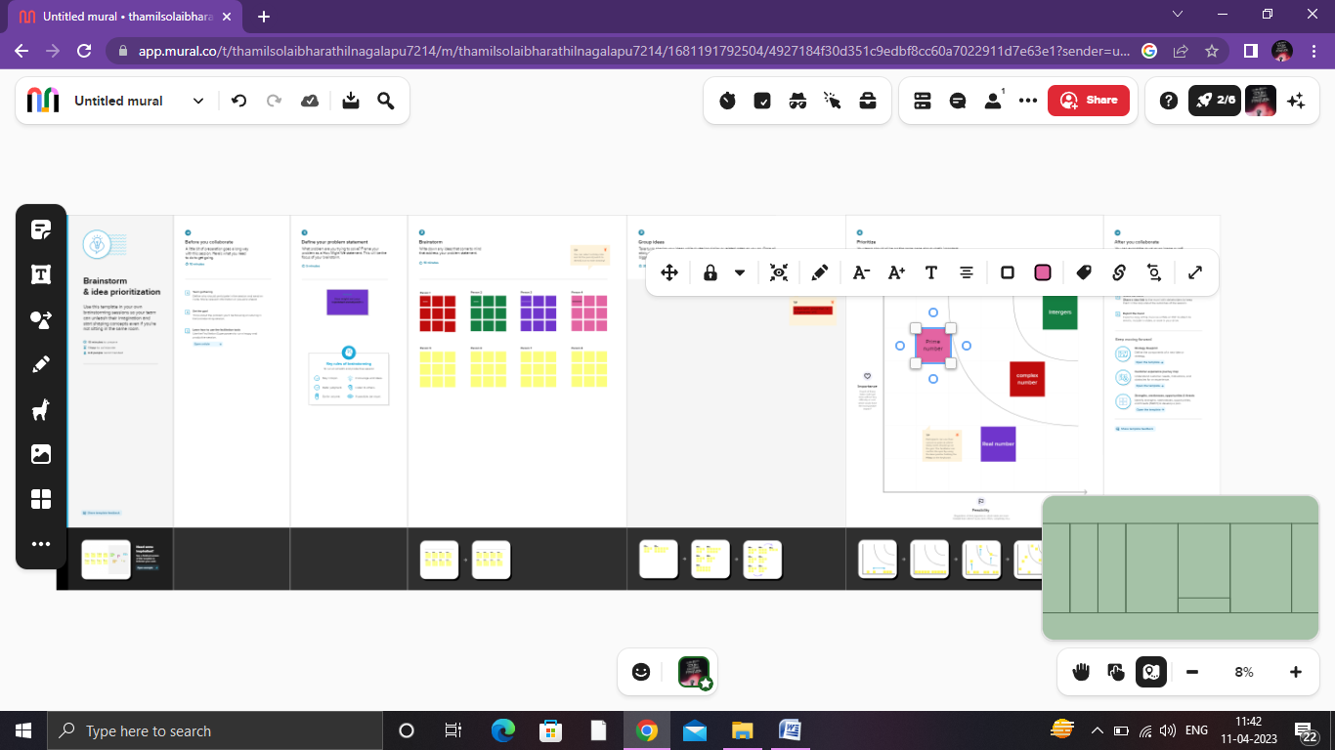

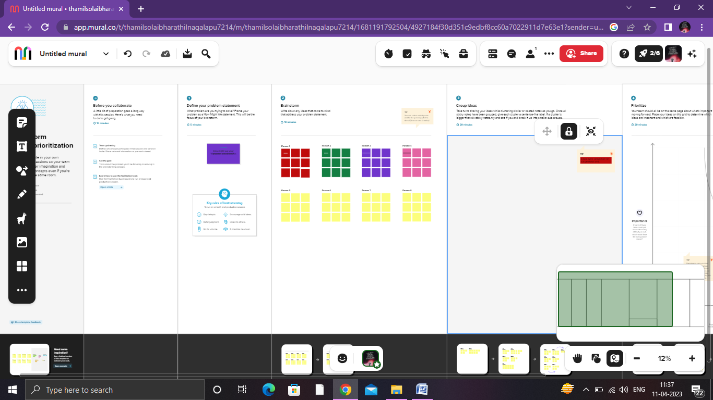

4.Trailhead Profile Public URL

Team Lead – <http://trailblazer.me/id/ssneka7>

Team Member 1 - <http://trailblazer.me/id/mkannan36>

Team Member 2 - <http://trailblazer.me/id/Thamil>

Team Member 3 - <http://trailblazer.me/id/tkalimuthu1>

5. Advantages :

* Easy to understand any real life problems.

* Mathematical Aptitude and Attitude

* Stimulates Brain cells

* Critical Thinking

* Develops Curiosity and passion

Disadvantages :

* Not necessarily a correct model

* Unrealistic models may fit data very well leading to erroneous conclusions

* Complexity is often required

* Realistic simulations require a large number of hard to obtain parameters

6.Applicaions :

*Mathematics is a deliberate utilization of issue

*The financial area is identified with mathematics; thus even the clients should be acquainted with it.

Conclusion

Trailblazer is one of the way to learning the mathematical concepts and trail of the many scope of the business and industries.

Future Scope

To develop the knowledge through cloud computing and Sharing many ideas of the real life problems.